1. **ReactJS-HOL**

**#**App.js

import React from 'react';

function App() {

return (

<div>

<h1>Welcome to the first session of React</h1>

</div>

);

}

export default App;

**#OUTPUT:**

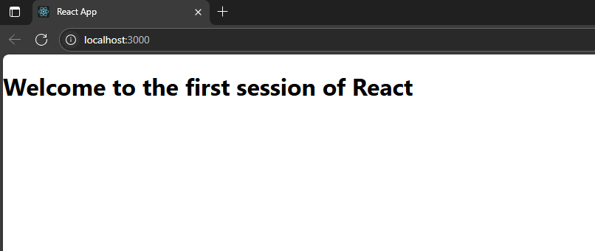

1. **ReactJS-HOL**

**# Home.js**

import React, { Component } from 'react';

export class Home extends Component {

render() {

return (

<div>

<h3>Welcome to the Home Page of Student Management Portal</h3>

</div>

);

}

}

**#About.js**

import React, { Component } from 'react';

export class About extends Component {

render() {

return (

<div>

<h3>Welcome to the About Page of Student Management Portal</h3>

</div>

);

}

}

**#Contact.js**

import React, { Component } from 'react';

export class Contact extends Component {

render() {

return (

<div>

<h3>Welcome to the Contact Page of Student Management Portal</h3>

</div>

);

}

}

**#App.js**

import './App.css';

import { Home } from './Components/Home';

import { About } from './Components/About';

import { Contact } from './Components/Contact';

function App() {

return (

<div className="container">

<Home />

<About />

<Contact />

</div>

);

}

export default App;

**#OUTPUT:**

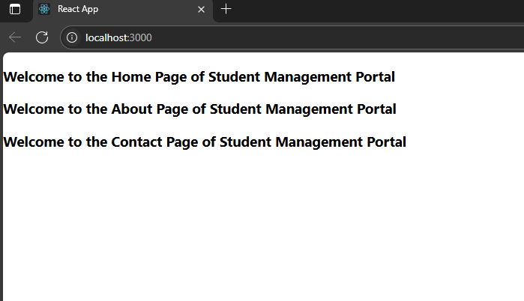

1. **ReactJS-HOL:**

**#CalculateScore.js**

import React from 'react';

import '../Stylesheets/mystyle.css';

const percentToDecimal = (decimal) => {

return (decimal * 100).toFixed(2) + '%';

};

const calcScore = (total, goal) => {

return percentToDecimal(total / goal);

};

export const CalculateScore = ({ Name, School, total, goal }) => (

<div className="formatstyle">

<h1><font color="Brown">Student Details:</font></h1>

<div className="Name">

<b>Name:</b> <span>{Name}</span>

</div>

<div className="School">

<b>School:</b> <span>{School}</span>

</div>

<div className="Total">

<b>Total:</b> <span>{total} Marks</span>

</div>

<div className="Score">

<b>Score:</b> <span>{calcScore(total, goal)}</span>

</div>

</div>

);

**# mystyle.css:**

**.**Name {

font-weight: 300;

color: blue;

}

.School {

color: crimson;

}

.Total {

color: darkmagenta;

}

.Score {

color: forestgreen;

}

.formatstyle {

text-align: center;

font-size: large;

}

#App.js

import './App.css';

import { CalculateScore } from './Components/CalculateScore';

function App() {

return (

<div>

<CalculateScore

Name={"Soham"}

School={"KIIT"}

total={284}

goal={300}

/>

</div>

);

}

export default App;

**OUTPUT:**

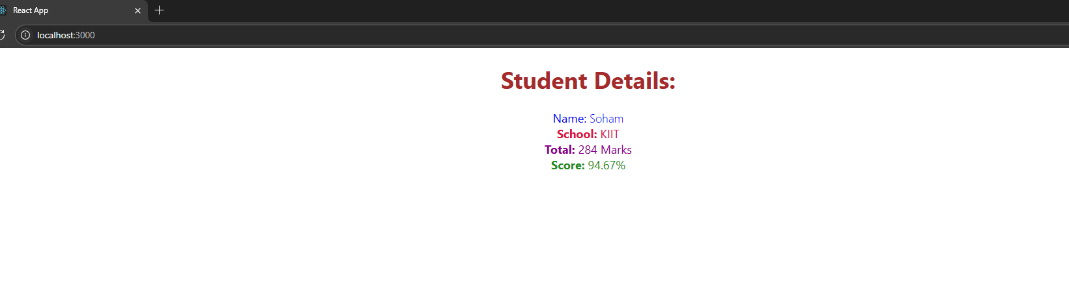

1. **ReactJS-HOL:**

**#Posts.js:**

import React from 'react';

class Posts extends React.Component {

constructor(props) {

super(props);

this.state = {

posts: [],

hasError: false,

};

}

loadPosts() {

fetch("https://jsonplaceholder.typicode.com/posts")

.then((response) => response.json())

.then((data) => {

const postList = data.slice(0, 5).map(post => ({

id: post.id,

title: post.title,

body: post.body,

}));

this.setState({ posts: postList });

})

.catch(error => {

console.error("Error fetching posts:", error);

this.setState({ hasError: true });

});

}

componentDidMount() {

this.loadPosts();

}

render() {

if (this.state.hasError) {

return <h2>Something went wrong while loading posts.</h2>;

}

return (

<div>

<h1>Latest Blog Posts</h1>

{this.state.posts.map((post) => (

<div key={post.id}>

<h3>{post.title}</h3>

<p>{post.body}</p>

<hr />

</div>

))}

</div>

);

}

componentDidCatch(error, info) {

console.error("Error caught in component:", error);

alert("An error occurred while rendering Posts.");

this.setState({ hasError: true });

}

}

export default Posts;

**#Post.js:**

class Post {

constructor(id, title, body) {

this.id = id;

this.title = title;

this.body = body;

}

}

export default Post;

**#App.js:**

import './App.css';

import Posts from './Posts';

function App() {

return (

<div className="App">

<Posts />

</div>

);

}

export default App;

**#OUTPUT:**

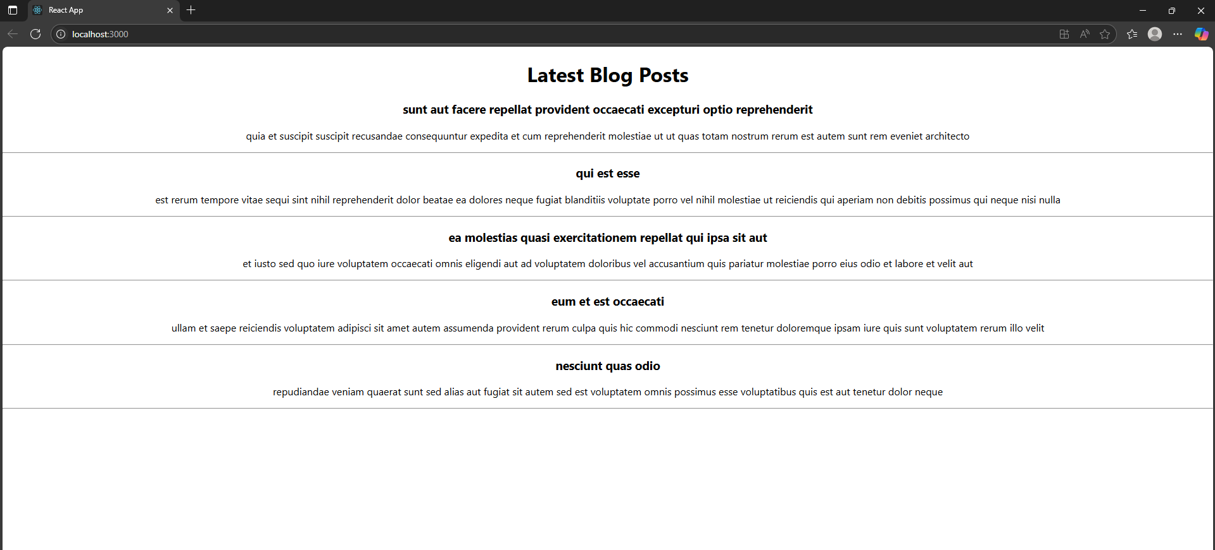

1. **ReactJS-HOL:**

**#CohortDetails.module.css:**

.box {

width: 300px;

display: inline-block;

margin: 10px;

padding: 10px 20px;

border: 1px solid black;

border-radius: 10px;

}

dt {

font-weight: 500;

}

**#CohortDetails.js :**

import React from 'react';

import styles from './CohortDetails.module.css';

const CohortDetails = ({ name, startDate, endDate, status }) => {

const headingStyle = {

color: status === 'ongoing' ? 'green' : 'blue',

};

return (

<div className={styles.box}>

<h3 style={headingStyle}>{name}</h3>

<dl>

<dt>Start Date:</dt>

<dd>{startDate}</dd>

<dt>End Date:</dt>

<dd>{endDate}</dd>

<dt>Status:</dt>

<dd>{status}</dd>

</dl>

</div>

);

};

export default CohortDetails;

**#App.js**

import './App.css';

import CohortDetails from './CohortDetails';

function App() {

return (

<div className="App">

<h1>Cohort Dashboard</h1>

<CohortDetails

name="React April Batch"

startDate="2025-04-01"

endDate="2025-07-01"

status="ongoing"

/>

<CohortDetails

name="Node March Batch"

startDate="2025-03-01"

endDate="2025-06-15"

status="completed"

/>

</div>

);

}

export default App;

**#OUTPUT:**

